MYSTERY MATCHUP

A Game for Beginning Strings

Sarah Morrison
Orchestra Director
Rochelle School of the Arts, Lakeland

Uses: This game requires each student to identify and demonstrate both the effective/correct and ineffective/ incorrect versions of several specific skills addressed in the first year of orchestra class. You can use this game to review good habits at the beginning or end of the semester.

Target skills:
Students will demonstrate
- Left-hand position checkpoints
- Good intonation on D, A, G strings in first position (basses, I and III pos.)
- Good pizzicato tone on fingered notes, with proper finger weight
- Bowhold checkpoints
- Good tone when playing arco, with attention to effective use of bow weight, contact point, angle, and bow speed
- Discrimination between down-bow and up-bow motions

What the game teaches:
Student learns to discriminate between the correct way to perform each skill and the incorrect way. To complete the game, each student must demonstrate his assigned skill correctly.

Prerequisites:
Students should be able to demonstrate and explain the following concepts:
- Left-hand position checkpoints (see “Detective”)
- Bowhold checkpoints (see “Detective”)
- Ringing tone
Pizzicato: Proper finger weight with relaxed, round fingers
Arco: Can we see and hear the big vibrations of the string?
Bow weight
Bow contact point
Bow speed
Bow hair perpendicular with string
- In tune vs. Out of tune (use ears and eyes)
- Down bow, Up bow

How to Play:
This is a modified version of the old-fashioned game “Old Maid.”
- Each student picks a card from the deck. Each card describes the wrong version of one specific skill from the first year of orchestra (laminate the cards on page of the Game Packet handout, or create your own). There are two copies of each card in the deck. Keep the contents of your card secret.
- Students circulate around the room with their instruments, taking turns performing for one another individually (a scale or short piece). They must demonstrate good playing habits except for the one listed on their card. Each student must demonstrate her assigned skill “all wrong,” according to the description on her card. All other playing habits must be correct, or you could find the wrong match!
- Each player seeks her match as she watches others perform. Who has the matching card?
- When you have found your match, practice performing the correct way with your partner.
- To complete the match, perform the scale/song for the class twice: once demonstrating the wrong way, once demonstrating the correct version.
- The class must guess what the card says. (What skill is being isolated?)

Variation:
- Give a prize for the best “correct” performance using a simple set of criteria:
Tone, Intonation, Rhythm, LH/RH Position.
- And if it’s the last week before the vacation…also give a prize for the best “worst” performance. (Don’t do this too often!)

MYSTERY MATCH-UP CARDS are included below (make two copies of each and cut out in card shape). You may laminate and cut out the templates provided. You can also make your own playing cards using index cards. Create your own target areas.

Mystery Match-Up Cards

Incorrect left hand position=
No mouse hole
“Pizza hand”

Poor intonation=
Fingers out of tune or “sour” (off tapes)

Poor pizzicato tone=
“Thuds” instead of Rings

Incorrect bow hold:
No bent thumb =“Banana thumb”
Stiff fingers holding on tips

Crooked bow (not parallel with bridge)

Bow is over fingerboard
(not in highway)


Too much bow weight=
Crunchy tone
“Elephant tone”


Too little bow weight=
Airy tone
“Water spider tone”

Starting on incorrect bow direction:
Start up-bow instead of down-bow


Card Sharks

A Game for Beginning Strings

Sarah Morrison
Orchestra Director
Rochelle School of the Arts, Lakeland

Uses: Use it as a way to review Rolland action exercises (or any exercises you like) in a fun and fast-paced way, allowing students to lead the activity.

Target skills: Relaxed and free movement in the development of left hand and arm, right hand
and arm, and playing stance

Prerequisites:
Students should be able to perform and identify by name each of the exercises listed above under “Action Exercises” (see Game #1: Gotcha!).

Before You Play:
Laminate and cut out the playing cards below, or make your own on index cards.

Time to Play:
- Have the students sit in a large circle, facing each other, with their instruments ready. Walk around the classroom holding out the playing cards in a fan. Each student takes one card and reads it.
- Have the student with the next birthday start the game. Each student comes into the middle of the circle and silently leads the exercise on his card. The class imitates his actions.
- The teacher picks the best copycat of each exercise to lead the next exercise (make sure everyone gets a turn to lead).

Variation: Beat the Clock:
- Set a timer. Go around the circle in order. Have each student lead the exercise on his card from his place in the circle.
- The class may not go to the next exercise until everyone is copycatting correctly (teacher circulates and gives guidance). Once you gone all the way around the circle, stop the timer. Write the class time on the board.
- Pass your cards one person to the left. Now go around the circle again. Try to beat the time written on the board.
- If your class is big, or the students tire, every other student can perform, or the teacher can time going half way around the circle.
Card Sharks

Left hand:

The “Railroad” (or “Shuttle”)

Railroad with whistle stops
(Shuttle with left hand pizzicato, or whistles, in 1st and middle positions)

Swing-strums
(Swing arm while strumming with 3rd and 4th fingers)

Finger bounces on D string:
E F# G

Finger bounces on A string:
B C# D

Thumb taps, Thumb slides


Leap-Frog Fingers
(Swing arm while hopping each finger from string to string)

Right hand:

Bowhold finger bounces:
Tap each finger on your bowhold

Butterfly Wing Kisses
(“Rock the bow”)

Seesaws
(“Roll the arm”)

Hot Air Balloon:
“Place and lift” bow


Instrument Placement:

Statue of Liberty


Sways:
Sway while in shoulder position keeping knees flexible

Swaying Cellos, Flying Cellos:
Sway, then fly with arms outstretched
(3-point support from chair, both feet)

Jaw sinks in the “jawrest” vs. Chin clamps on chinrest
(demonstrate supported vs. “clamped”)
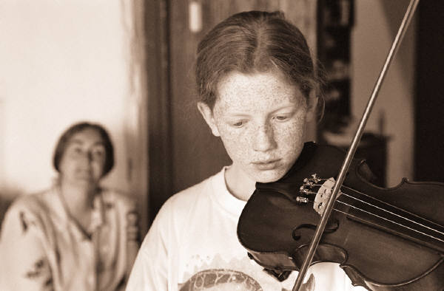

Look, Mom—No Hands!:
Pat the right shoulder with the left hand
Drop the arm & support with the shoulder/jaw

Spaghetti noodle arms:
Drop the arm & support with the shoulder/jaw
Swing arms

