5th Grade Beginning Strings

Pencil Bow Hold Checkpoints

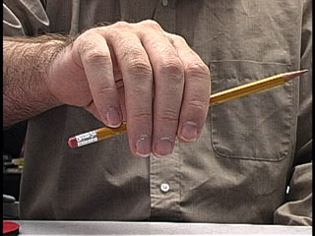
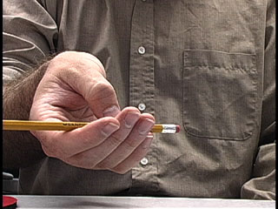

4=Exemplary 3=Proficient 2=Developing 1= Does not demonstrate

Bent Thumb 1 2 3 4

Round Fingers 1 2 3 4

Middle and ring fingers 1 2 3 4
touch pencil inside first joint

Middle fingers form a circle 1 2 3 4
with thumb

Round pinky on tip 1 2 3 4

Pointer finger touches 1 2 3 4
pencil between first and
second joint

Fingers evenly spaced 1 2 3 4

